**BBA(CA) 4602 – Ecommerce**

Question bank

1. **DEFINE ECOMMERCE. EXPLAIN ITS ACTIVITIES AND GOALS**

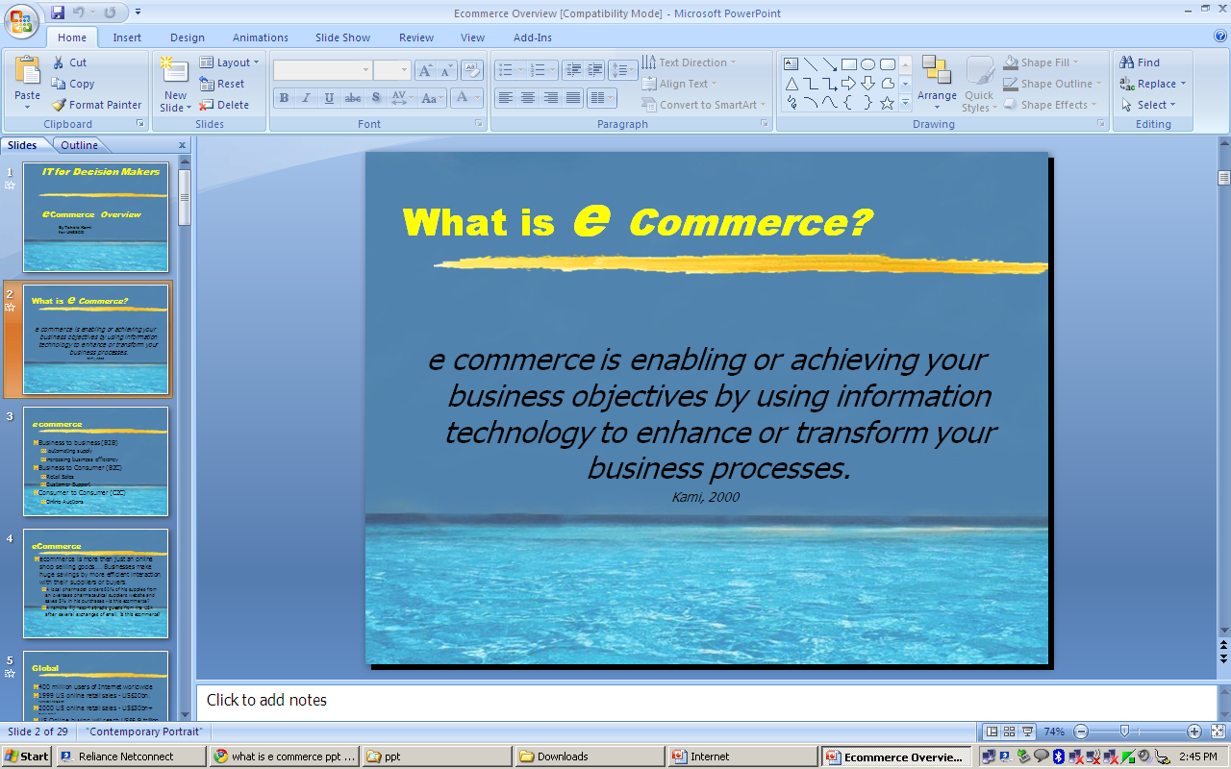

**Main Activities of Electronic Commerce –**

Buying and Selling of Products- This activity involves providing product information, price details on the Internet to enable a customer to buy a product online

Shipping of Products- The purchased products have to be delivered to the respective customer

Producing Financial statements – Business deals are settled electronically by EDI and EFT. The Digitally signed documents are exchanged.

**Broad Goals of Electronic Commerce –**

Reduced costs

Lower product cycle time

Faster customer response

Improved service quality

1. **Advantages/ Disadvantages of Ecommerce**

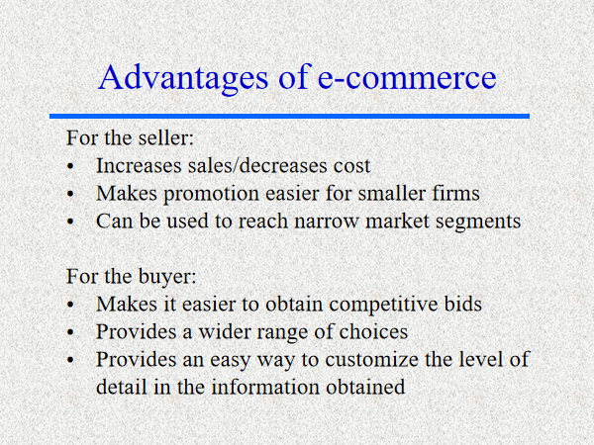

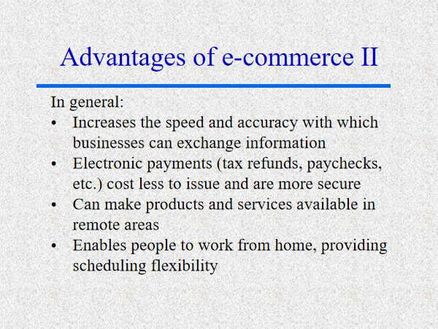

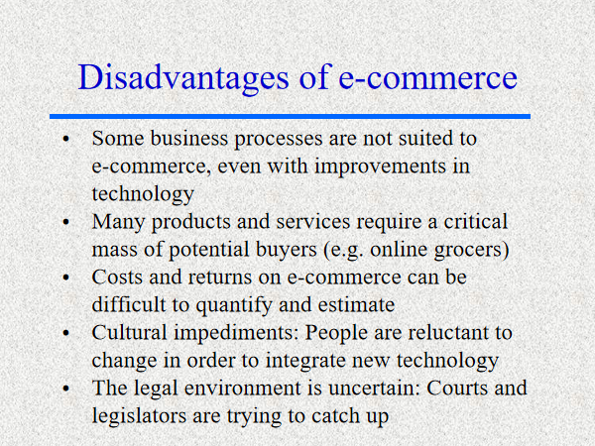

1. **Explain B2C, B2B and C2C business model with example**

**Business to Consumer Ecommerce**

Business-to-consumer (B-to-C) electronic commerce is online retailing or e-tailing. It involves consumers shopping for and buying personal and household products. It involves merchants using electronic marketing and merchandising techniques to attract and retain customers as well as to promote products and services to them.

**Business to Business Ecommerce**

Business-to-business (B-to-B) electronic commerce covers a broad range of business activities. For example, B-to-B systems exchange business documents, such as purchase orders and invoices, between pairs of partners in a supply chain. They may implement a virtual marketplace (e-marketplaces or exchanges), wherein a single large manufacturer can consolidate the purchase of the goods that are the input to its manufacturing process from many smaller companies. Such a marketplace may enable a large retailer to purchase the goods that it sells in its stores. Or, marketplaces can become trading marts or exchanges for commodity products or the range of products of a given type or associated with a particular industry segment. B-to-B systems also automate the purchase of goods that support businesses’ maintenance, repair, and operation (MRO).

**Consumer-to-consumer (C2C) (or citizen-to-citizen)** **[electronic commerce](http://en.wikipedia.org/wiki/Electronic_commerce" \o "Electronic commerce)** involves the electronically-facilitated transactions between consumers through some third party. A common example is the [online auction](http://en.wikipedia.org/wiki/Online_auction" \o "Online auction), in which a consumer posts an item for sale and other consumers bid to purchase it; the third party generally charges a [flat fee](http://en.wikipedia.org/wiki/Flat_fee" \o "Flat fee) or [commission](http://en.wikipedia.org/wiki/Commission_(remuneration)" \o "Commission (remuneration)). The sites are only intermediaries, just there to match consumers. They do not have to check quality of the products being offered.

## Examples of C2C:

* [Quikr.com](http://en.wikipedia.org/wiki/EBay" \o "EBay)
* [OLX](http://en.wikipedia.org/wiki/Amazon.com" \o "Amazon.com).com

1. **Explain any 2 E-governance schemes in India**

India has been rapidly adopting e-governance initiatives to promote transparency, efficiency, and effectiveness in the delivery of government services to citizens. Here are two examples of e-governance schemes in India:

**Aadhaar:**

Aadhaar is a 12-digit unique identification number issued by the Unique Identification Authority of India (UIDAI) to residents of India. It is a biometric-based identification system that captures an individual's demographic and biometric information, such as fingerprints, iris scans, and photographs, and stores it in a centralized database. Aadhaar has become a game-changer in India's e-governance landscape by enabling the government to deliver various welfare schemes and services directly to the targeted beneficiaries.

**Benefits of Aadhaar:**

* Elimination of middlemen and duplication of beneficiaries
* Efficient delivery of welfare schemes and services
* Reduction in leakages and corruption
* Ease of accessing banking and financial services
* Promotes financial inclusion

**Examples of Aadhaar-enabled services:**

* Direct Benefit Transfer (DBT) for LPG subsidy, PDS, and various other schemes
* Jan Dhan Yojana for opening bank accounts
* Digital Locker for storing documents
* DigiLocker for storing and sharing digital certificates and documents
* e-KYC for instant verification of identity and address proof

**e-NAM:**

e-NAM (National Agriculture Market) is an online trading platform for agricultural commodities that was launched in 2016 by the Ministry of Agriculture and Farmers Welfare. It is a pan-India electronic trading portal that provides a single window service for all APMC-related information and services. The objective of e-NAM is to create a unified national market for agricultural commodities and to enable farmers to get better prices for their produce.

**Benefits of e-NAM:**

1. Greater transparency in pricing and quality of agricultural produce
2. Access to a wider market and better price discovery
3. Reduction in intermediaries and transportation costs
4. Efficient supply chain management
5. Elimination of physical market barriers

**Examples of e-NAM services:**

1. Farmer registration and creation of virtual warehouses
2. Online bidding and trading of agricultural produce
3. Integration with e-Payment systems
4. Integration with quality testing and grading agencies
5. Real-time information on market prices and trends

In conclusion, Aadhaar and e-NAM are two exemplary e-governance schemes that have revolutionized the way government services are delivered to citizens and farmers in India. These schemes have the potential to drive India's economic growth and improve the standard of living for millions of people in the country.

1. **What are the benefits of E-governance?**

E-governance or electronic governance refers to the use of Information and Communication Technologies (ICTs) by governments to enhance the delivery of services and improve the functioning of government machinery. Here are some benefits of e-governance:

1. Improved transparency: E-governance initiatives enable citizens to access information and services in a transparent and efficient manner.
2. Example: The Right to Information Act, 2005, provides citizens with the right to seek information from public authorities through electronic means.
3. Increased accessibility: E-governance initiatives promote greater accessibility to government services for citizens, regardless of their location or socio-economic status.
4. Example: The Digital India campaign aims to provide digital infrastructure and services to every citizen, including those in remote areas.
5. Reduced corruption: E-governance can help reduce corruption by minimizing human intervention and promoting accountability and transparency.
6. Example: The use of Aadhaar for direct benefit transfers has reduced leakages and corruption in government schemes.
7. Efficient service delivery: E-governance initiatives enable governments to provide services in a faster, more efficient, and cost-effective manner.
8. Example: The e-District project in India provides citizens with a one-stop-shop for various district-level services such as certificates, licenses, and permits.
9. Better decision-making: E-governance can provide policymakers with real-time data and information, enabling them to make better decisions.
10. Example: The National Crime Records Bureau uses ICTs to gather and analyze crime data to help policymakers formulate crime prevention strategies.
11. Enhanced citizen participation: E-governance can facilitate greater citizen participation in the decision-making process and improve governance accountability.
12. Example: The MyGov platform enables citizens to provide feedback, suggestions, and ideas to the government on various policy issues.
13. Increased efficiency in the public sector: E-governance can improve the efficiency of public sector organizations by automating processes, reducing paperwork, and improving communication.
14. Example: The National Informatics Centre provides ICT solutions and services to government departments to improve their functioning.
15. Improved delivery of healthcare services: E-governance initiatives can help improve the delivery of healthcare services by providing remote healthcare consultations and services.
16. Example: The eSanjeevani platform provides telemedicine services to citizens across India.
17. Promotes financial inclusion: E-governance initiatives can help promote financial inclusion by providing citizens with access to banking and financial services.
18. Example: The Jan Dhan Yojana provides financial inclusion to the unbanked population in India by providing bank accounts and insurance schemes.
19. Improved education: E-governance can improve the quality of education by providing access to digital learning resources and promoting remote learning.
20. Example: The SWAYAM platform provides free online courses to students across India.
21. Promotes entrepreneurship: E-governance initiatives can promote entrepreneurship by providing access to digital platforms for business registration and other services.
22. Example: The e-Biz platform provides a single-window service for businesses to register and obtain various licenses and permits.
23. Improves disaster management: E-governance initiatives can improve disaster management by providing real-time information and communication during natural disasters.
24. Example: The National Disaster Management Authority uses ICTs to disseminate disaster-related information to citizens and emergency services.
25. Promotes environmental sustainability: E-governance can promote environmental sustainability by providing access to environmental data and monitoring tools.
26. Example: The Pollution Control Board uses ICTs to monitor and regulate pollution levels in various industries.
27. Enhanced tourism: E-governance initiatives can help promote tourism by providing digital tourism information and services to tourists.
28. Example: The Incredible India website provides tourists with information on tourism destinations, travel itineraries, and other tourism-related services.
29. Improved public safety: E-governance initiatives can improve public safety by providing real-time crime data and other public safety information

**6) Explain the E-governance models**

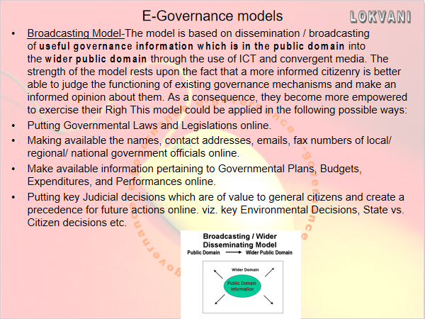

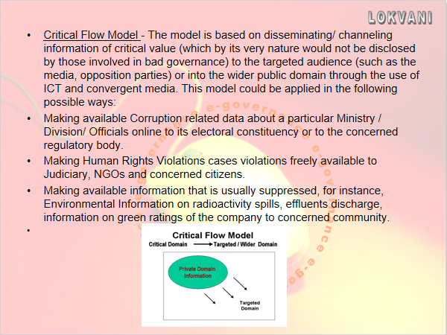

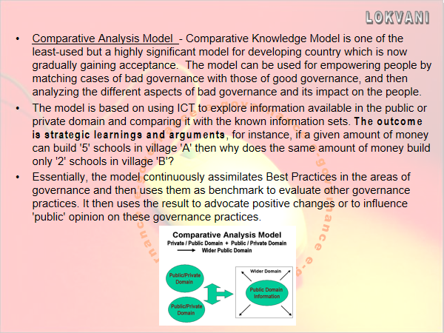

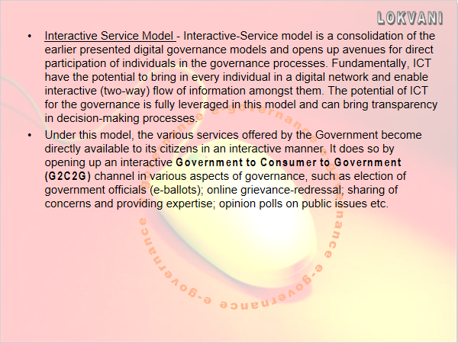

**7. Define EDI. Explain EDI model**

**What is EDI?**

What is Electronic Data Interchange (EDI)? The purpose of this article is to provide a layperson's understanding of the electronic data interchange process. An overview of EDI benefits and drawbacks is included.

The electronic data interchange process is the computer-to-computer exchange of business documents between companies. EDI replaces the faxing and mailing of paper documents.

EDI documents use specific computer record formats that are based on widely accepted standards. However, each company will use the flexibility allowed by the standards in a unique way that fits their business needs.

EDI is used in a variety of industries. Over 160,000 companies have made the switch to EDI to improve their efficiencies. Many of these companies require all of their partners to also use EDI.

**Overview of EDI benefits and drawbacks**

The EDI process provides many benefits. Computer-to-computer exchange of information is much less expensive than handling paper documents. Studies have shown that manually processing a paper-based order can cost $70 or more while processing an EDI order costs less than one dollar.

* Much less labor time is required
* Fewer errors occur because computer systems process the documents rather than processing by hand
* Business transactions flow faster.

Faster transactions support reduction in inventory levels, better use of warehouse space, fewer out-of-stock occurrences and lower freight costs through fewer emergency expedites.

Paper purchase orders can take up to 10 days from the time the buyer prepares the order to when the supplier ships it. EDI orders can take as little as one day.

One drawback to EDI is that companies must ensure that they have the resources in place to make an EDI program work; however, the need for buying and hiring these resources or outsourcing them may be offset by the increased efficiency that EDI provides.

**EDI example**

Here is an example of how the electronic data interchange process works. A buyer prepares an order in his or her purchasing system and has it approved.

Next, the EDI order is translated into an EDI document format called an 850 purchase order.

The EDI 850 purchase order is then securely transmitted to the supplier either via the internet or through a VAN (Value Added Network).

If the purchase order is sent using a VAN, then the buyer’s VAN interconnects with the supplier’s VAN. The VANs make sure that EDI transactions are sent securely and reliably. The supplier’s VAN ensures that the supplier receives the order.

The supplier’s computer system then processes the order.

Data security and control are maintained throughout the transmission process using passwords, user identification and encryption. Both the buyer’s and the supplier’s EDI applications edit and check the documents for accuracy.

**EDI requirements**

Each trading partner has unique EDI requirements. These will include the specific kinds of EDI documents to be processed, such as the 850 purchase order used in the example above, 856 advance ship notices and 810 invoices.

Almost any business document that one company wants to exchange with another company can be sent via EDI. However each EDI document must be exchanged with the partner in exactly the format they specify.

Many partners will have an [EDI implementation](http://www.covalentworks.com/edi-solution-implementation-process.asp) guide or kit that explains their specific requirements. Maps are required to translate the EDI documents from the trading partner’s format into the format that is useable by the receiving party.

Meeting all of an EDI trading partner's EDI requirements is called being EDI compliant.

**What you need to be EDI compliant**

EDI compliance involves either buying or outsourcing the following components:

1. Software for communications
2. VAN service for EDI transmission
3. Mailboxing of EDI transactions
4. Mapping and translation software
5. Installing upgrades to software as needed
6. Mapping labor
7. Testing with EDI trading partners
8. Upgrades for new versions required by trading partners

EDI VAN, FTP, or AS/2 Internet communications will be required by various partners. A server or PC, communication devices and peripherals will be needed as well as secured office space, monitored security, backups and redundant power.

Additional software will be needed if integration of the EDI transactions with back office systems is desired. Personnel must be trained in how to use the software and communication devices. Maps will then need to be developed, tested and maintained.

1. **What is the cost involved in EDI?**

**TODO**

**9) Define EPS. Describe any 2 modes of EPS**

**TODO**

1. **Explain Credit card payment system and GIRO**

**TODO**

1. **Explain Micropayment and Smart card**

**TODO**

1. **Write a note on RTGS and NEFT**

**13) Explain E-cash and E-cheque**

**E-CHeque**

Electronic cheques are another form of Electronic tokens. They are designed to accommodate the many individuals and entities that might prefer to pay on credit or through some mechanism other than cash. Once registered, a buyer can then contact sellers of goods and services. To complete a transaction, the buyer sends a check to the seller for a certain amount of money. These checks may be sent using Email or other Transport methods. When deposited, the cheque authorises the transfer of account balances from the account against which the cheque was drawn to the account to which the cheque was deposited.  
The electronic cheques are modeled on paper checks, except that they are initiated electronically. They use digital signatures for signing and endorsing and require the use of digital certificates to authenticate the payer, the payer’s bank and bank account. They are delivered either by direct transmission using telephone lines or by public networks such as the Internet.

**Benefits of electronic Cheques:**  
• Well suited for clearing micro payments. Conventional cryptography of e-cheques makes them easier to process than systems based on public key cryptography (like digital cash).  
• They can serve corporate markets. Firms can use them in more cost-effective manner.  
• They create float and the availability of float is an important requirement of Commerce.

**Advantages of Electronic cheques:**  
1. Similar to traditional cheques. This eliminates the need for customer education  
2. Since Electronic cheques use conventional encryption than Public and private keys as in e-Cash, Electronic cheques are much faster.

**eCash IN ACTION**

eCash is based on cryptographic systems called Digital Signatures. This method involves a pair of numeric keys (very large integers or numbers) that work in tandem: one for locking (or encoding) and the other for unlocking (decoding). Messages encoded with one numeric key can only be decoded with the other numeric key and none other. The encoding key is kept private and the decoding key is made public.

By supplying all customers (buyers and sellers) with its public key, a bank enables customers to decode any message (or currency) encoded with the bank’s private key. If decoding by a customer yields a recognizable message, the customer can be fairly confident that only the bank could have encoded it. These digital signatures are as secure as the mathematics involved and have proved Over the past two decades to be more resistant to forgery than handwritten signatures.

Before eCash can be used to buy products or services, it must be procured from a Currency server.

**PURCHASING eCash FROM CURRENCY SERVER**

eCash can be purchased from an On – Line currency server in 2 steps namely, Establishing an account and maintaining enough money in the account to back the purchase.

**How Actually eCash will work**

1. The user of eCash has to have an Account with a bank ready to offer eCash.
2. The user will apply for eCash in the denomination and amount the he desires. In exchange of money debited from the customer’s account, the bank uses its private key to digitally sign the note for the amount requested and transmits the note back to the customer. The network currency server in effect is issuing a "bank note" with a serial number and a dollar amount.
3. Since the bank is digitally signing it, the bank is committing itself.
4. The user has the eCash available. He can sign the eCash and give it to anybody.
5. When the eCash software generates a note, it masks the original number or "blinds" the note. The blinding carried out makes it impossible for anyone to link Payment to Payer.
6. A central bank also maintains a database of Spent notes.

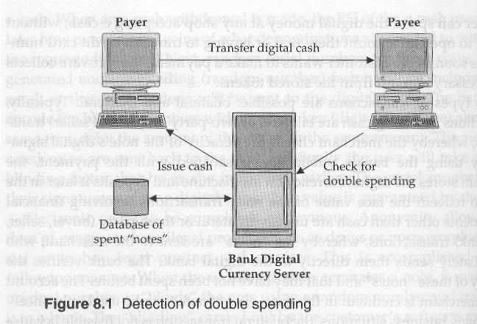

**14) Explain the services provided by M-commerce**

**TODO**

**15) Describe the advantages of M-commerce**

**TODO**

**16) What are the different threats to Information security? Explain**

**TODO**

**17) Define Virus. Explain any 2 types**

**TODO**

**18) Explain Macro virus, Stealth virus and Polymorphic virus**

**Macro viruses** typically infect global settings files such as Word templates so that subsequently edited documents are contaminated with the infective macros. Macro Viruses are the newest type of virus, these clever programs make use of the built-in programming languages in popular programs such as Microsoft Word and Microsoft Excel. These programs allow users to create programs that automate tasks, called *macros*. As the macro languages have become more powerful, virus writers have created malevolent macros that, when opened unwittingly, duplicate themselves into other documents and spread just like a conventional virus would. These programs can cause just as much damage as regular viruses, despite the fact that they are very different: regular viruses are low-level machine language programs, while macro viruses are actually high-level interpreted BASIC programs! The most common type of macro virus right now infects Microsoft Word documents.  
**STEALTH VIRUSES -** viruses that go to some length to conceal their presence from programs which might notice.  
**5) POLYMORPHIC VIRUSES** - viruses that cannot be detected by searching for a simple, single sequence of bytes in a possibly-infected file, since they change with every replication.

**19) Explain cryptography in detail**

**TODO**

**20) What is Encryption and Decryption in detail**

**TODO**

**21) What are the security measures to be taken against data threat?**

**TODO**

**22) Write a note on Digital signature**

**TODO**

**23) What is a Firewall? Explain**

**TODO**

**24) What are the different Data Recovery methods? Explain in detail**

**TODO**

**25) Write a note on VPN**

A Virtual Private Network (VPN) is a technology that creates a secure and encrypted connection over the internet between a user's device and a remote server. The encrypted connection masks the user's internet activity from anyone who may be monitoring it, including internet service providers, government agencies, and cybercriminals. VPNs provide users with a secure and private way to access the internet, protect their online privacy, and bypass geographic restrictions.

VPN works by routing a user's internet traffic through an encrypted tunnel to a remote server located in a different location than the user. This makes it appear as if the user is accessing the internet from the location of the remote server, rather than their actual location. VPNs use different types of protocols such as OpenVPN, PPTP, L2TP, and IKEv2 to establish secure connections.

**Here are some examples of how VPNs are used:**

Remote Work: With the increase in remote work, VPNs are being widely used by companies to enable their employees to access their corporate network securely from remote locations. This ensures that sensitive data is transmitted securely over the internet, and employees can access their work resources as if they were in the office.

Online Privacy: VPNs are popular among individuals who want to protect their online privacy and keep their internet activity hidden from prying eyes. VPNs prevent internet service providers from tracking user activity and keep online activity from being monitored by cybercriminals, hackers, and other malicious actors.

Bypassing Geo-Restrictions: VPNs can be used to bypass geo-restrictions imposed by governments and websites. For example, a person living in a country where certain websites are blocked can use a VPN to connect to a server located in a different country where those websites are accessible.

Streaming Services: VPNs are also used to access streaming services that may be geo-restricted in certain regions. By connecting to a VPN server located in a country where the streaming service is available, users can access the service and stream their favorite shows and movies.

Online Gaming: VPNs can be used to reduce latency and improve the gaming experience for online gamers. By connecting to a VPN server located closer to the game server, gamers can reduce lag and improve their overall gaming experience.

In summary, VPNs are a powerful tool for securing internet connections and providing users with privacy and anonymity. They can be used for remote work, online privacy, bypassing geo-restrictions, streaming services, and online gaming.

**26) Explain the 4 pillars of E-governance.**

The four pillars of e-governance are process, people, technology, and resources. These pillars are essential for the successful implementation of e-governance initiatives.

Process: The process refers to the way in which e-governance initiatives are planned, designed, implemented, and monitored. The process should be transparent, efficient, and user-friendly. For example, the implementation of online passport applications in India has streamlined the process and reduced the time taken to obtain a passport.

People: People are the most crucial element of e-governance initiatives. It involves creating awareness among citizens about the benefits of e-governance, training government officials to use technology, and engaging citizens in the decision-making process. For example, the MyGov platform in India allows citizens to participate in policy-making and governance by providing suggestions, feedback, and ideas.

Technology: Technology plays a vital role in e-governance initiatives. It involves the use of advanced tools and technologies to create efficient, reliable, and secure systems. For example, the use of biometric authentication in the Aadhaar system in India has enabled the government to provide citizens with a unique identification number, which is used for various e-governance services.

Resources: Resources refer to the financial, human, and technical resources required for the successful implementation of e-governance initiatives. It includes funding for technology infrastructure, skilled human resources, and technical support. For example, the Digital India initiative in India aims to provide broadband connectivity to all villages, which requires significant investment in infrastructure and resources.

In conclusion, the four pillars of e-governance, i.e., process, people, technology, and resources, are interdependent and critical for the successful implementation of e-governance initiatives. By leveraging these pillars, governments can create efficient, transparent, and citizen-centric governance systems.

**27) What are the advantages of Ecommerce**





1. **What is a Website? Explain Domain**

A website is a collection of web pages that are hosted on a web server and can be accessed through the internet using a web browser. Websites can be created for various purposes, such as to provide information, sell products or services, or entertain users.

A domain is the unique name that identifies a website on the internet. It is the part of the website's URL that comes after the protocol (such as http:// or https://) and before the first forward slash (/). The domain name is used to locate and access the website on the internet.

For example, in the URL https://www.google.com/, the domain name is "google.com". The ".com" part is the top-level domain (TLD) which signifies the type of website (in this case, a commercial website). There are many other TLDs available such as .org (for non-profit organizations), .gov (for government websites), and .edu (for educational institutions).

Domains can be registered through domain name registrars such as GoDaddy, Namecheap, and Google Domains. The registration process involves choosing an available domain name, providing contact and payment information, and agreeing to the terms and conditions of the registrar.

Once a domain is registered, it can be used to host a website and create email accounts with that domain name. For example, a company may register the domain "example.com" and use it to host its website at "www.example.com" and create email accounts such as "info@example.com" and "support@example.com".

In summary, a website is a collection of web pages hosted on a web server, while a domain is the unique name that identifies a website on the internet. Domains can be registered through domain name registrars and used to host websites and create email accounts.